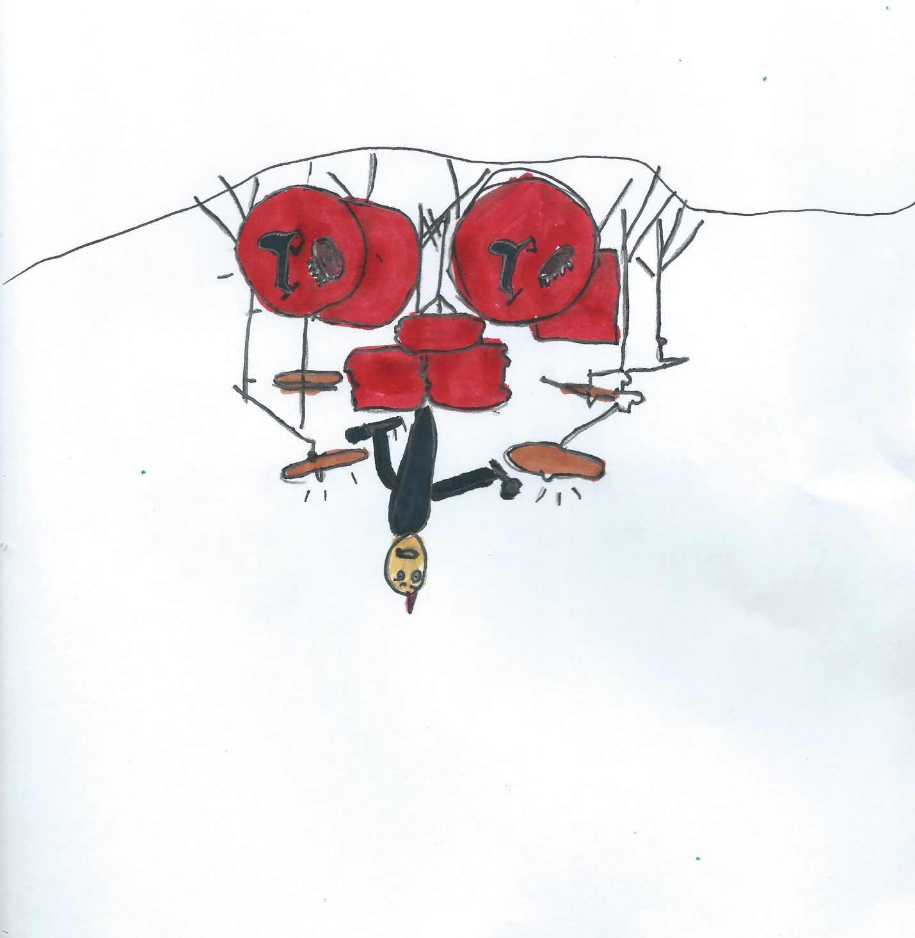
Ben Sims: a Biography
By Wynn Keppinger
12/11/20

This book is dedicated to Ben Sims.
He inspired me to learn how to play drums.

Ben Sims is a drummer for Brantley Gilbert, a country singer. He likes drumming a lot!
Ben was born in Gillsville, Georgia. He taught himself to play drums. He began playing music at the age of seven. His first live show was at the age of nine.

Ben was hired by Brantley Gilbert in 2008. His first album debuted in 2011. Some of the songs he’s drummed for include: “Fire’t- Up”, “Read me my Rights”, “Bottoms Up”, “The Weekend”, “Bro Code”, and “Kick it in the Sticks”.
He has advice for young drummers. He says, “You can do anything that you put your mind to and practice with a metronome”.
About the Biographer

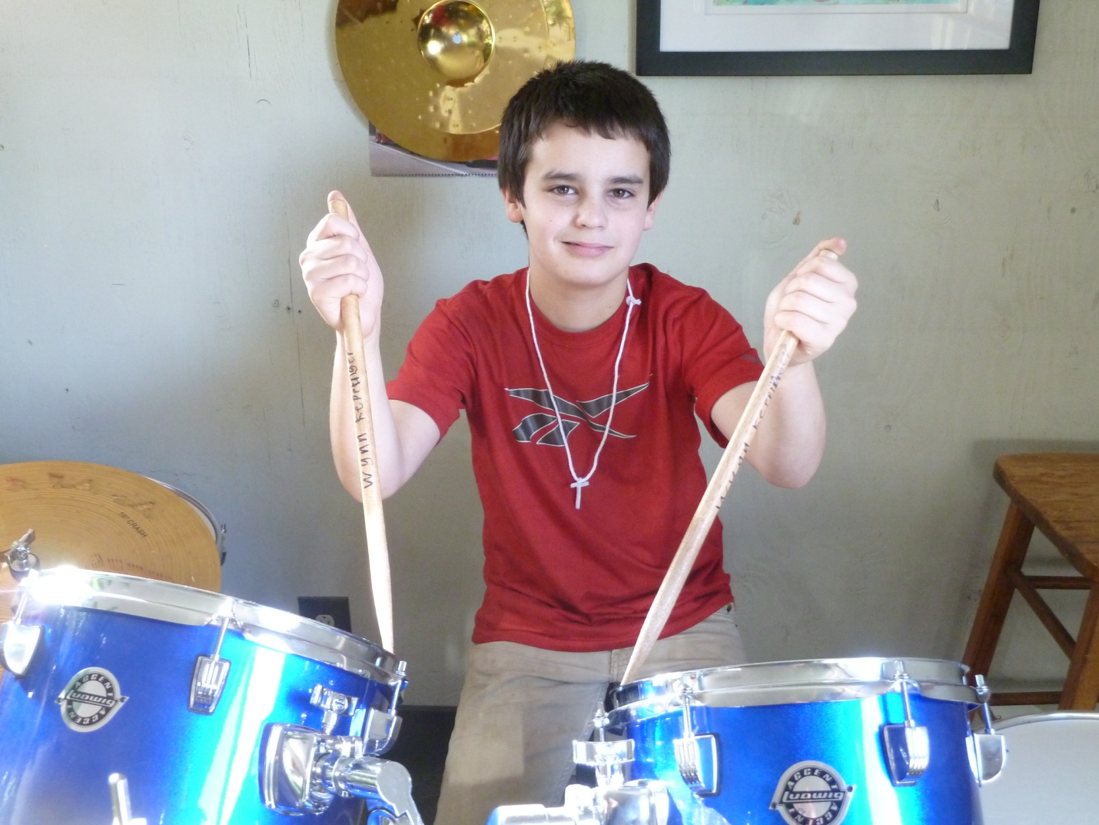
Author Wynn Keppinger is ten years old. He wishes he lives in Australia, but He lives in Oregon with his Mama and Papa, Sky his dog, and Indy his cat. Wynn likes trucks, guns, Lego sets, friends, knives and other boy-stuff like that, but he especially likes playing his drums and practices every day.

Sources

https://www.innovativepercussion.com/artists/ben_sims

https://sabian.com/artist/ben-sims/

